
Department | FED
Subject | DSA-2
Academic Year | I-III Semester (2025-26)
Faculty Name | RAZIA BANU
Student Name | P SHASHE PREETHAM
Roll Number | 2520030534
Branch | CSE
Course Outcome | CO1

Case Study Topic: MediFlow Hospital Patient Index using BST & AVL Tree (Set 1 Q1)
Work Done Summary:
In this case study, we implemented both BST and AVL Tree to manage patient records using Patient IDs. The IDs were inserted in appointment order, resulting in a nearly sorted sequence. We observed that the BST became skewed and inefficient for searching. To overcome this issue, an AVL Tree was implemented with automatic balancing using rotations. The height and performance of both structures were compared. The results showed that AVL Trees maintain O(log n) operations and provide faster lookups in hospital management systems.

Implementation Details:
- Inserted Patient IDs into BST and AVL Tree.
- Observed BST degeneration due to sorted input.
- Applied AVL rotations (LL, RR, LR, RL).
- Compared tree heights and lookup performance.
- Verified AVL maintained O(log n) operations.

Result: Screenshots / Output
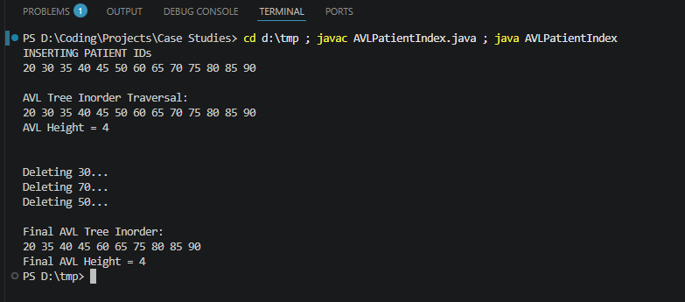
Result / Output
AVL Insertion Sequence
20, 30, 35, 40, 45, 50, 60, 65, 70, 75, 80, 85, 90
Patient IDs (Inorder Traversal)
20 30 35 40 45 50 60 65 70 75 80 85 90
AVL Height: 4
Final AVL Tree (Inorder Traversal After Deletions)
20 35 40 45 60 65 75 80 85 90
Final AVL Height: 4
Observations
- AVL Tree remained balanced after all insertions.
- Required rotations were performed automatically.
- Tree height remained logarithmic despite sorted input.
- Deletion of 30, 70, and 50 maintained AVL balance.
- Final AVL Tree continued to support efficient searching.
Time Complexity
- BST Worst Case Search/Insert/Delete: O(n)
- AVL Search: O(log n)
- AVL Insert: O(log n)
- AVL Delete: O(log n)
- AVL Rotation (LL, RR, LR, RL): O(1)

GITHUB LINK : https://github.com/tanyasri1405/case-study-DSA.git

Student Signature | Faculty Signature

